|  |
| --- |
| **Coronavirus (COVID-19): Risk Assessment Action Plan**  **This document should be read in conjunction with the schools outbreak management plan.** |

**Old Park School**

|  |  |
| --- | --- |
| Assessment conducted by: J Colbourne | Job title: Head teacher |
| Date of original assessment: 03.09.2021 | Date of next review:w.b. 01.11.2021 |
| Approved by: Mr Alex Burns (Chair of Governors) | Date reviewed: 16.09.2021, 21.10.2021 |

For the purpose of this risk assessment, the term ‘coronavirus’ to refer to coronavirus disease 2019 (COVID-19). Schools must ensure that this risk assessment reflects the local setting and context of the school. Staff must be consulted with regard to this risk assessment (this must take into consideration all types of workers including agency workers, casual staff and contractors and any other adult on site as well as your permanent staff). This risk assessment should be read in conjunction with Government, Local Authority and Public Health guidance.

The following guidance was updated on the 27th September 2021 and relates specifically to special schools and other specialist settings.

<https://www.gov.uk/government/publications/guidance-for-full-opening-special-schools-and-other-specialist-settings/guidance-for-full-opening-special-schools-and-other-specialist-settings>

**The system of controls: protective measures**

Having assessed their risk, settings should work through this system of controls, adopting measures in a way that:

* addresses the risk identified in their assessment
* works for their setting, and the individual, often complex, needs of the children and young people they teach
* allows them to deliver a broad and balanced curriculum, including full educational and care support for their pupils and students

If settings take steps to follow the guidance set out here they will effectively reduce risks in their setting and create an inherently safer environment.

|  |
| --- |
| Control Measures **You should:**   * Ensure good hygiene for everyone. * Maintain appropriate cleaning regimes. * Keep occupied spaces well ventilated. * Follow public health advice on testing, self-isolation and managing confirmed cases of COVID-19. |

All employers are required to take steps to reduce the risk of exposure to COVID-19 in the workplace and should be able to explain what measures they have put in place to keep their employees safe at work.

Whilst individual risk assessments are not required, employers are expected to discuss any concerns that people previously considered CEV may have.

|  |  |  |  |  |  |  |
| --- | --- | --- | --- | --- | --- | --- |
| **Key:** | |  | | | | |
| Level of risk prior to control | | Identifies the risk before any steps to reduce the risk have been taken | | | | |
| Risk Description: | | Outlines the area of concern. | | | | |
| Risk Controls: | | The measures that will be taken to minimise the risk. | | | | |
| Likelihood: | | Could be L/M/H or numeric, depending on what is used in the school setting. | | | | |
| **Area** | **Risk** | | **Level of Risk Prior to Control** | **Control Measures** | **Level of Risk After Control** | **Likelihood** | |
| Guidance and policies | The school lapses in following national guidelines and advice, putting everyone at risk | | High | Ensure that all relevant guidance is followed and communicated.  Daily checks are made with the Government online guidance.  Government guidance may be issued overnight, checks must be made prior to opening each day.  The school to keep up-to-date with advice issued by, but not limited to, DfE, NHS, Department of Health and Social Care and PHE, and review its risk assessment accordingly  Information on the school website is updated.  Any change in information to be shared with Chair of Governors and passed on to parents and staff by website/social media – notified by School Life.  As a result, the school has the most recent information from the government, and this is distributed throughout the school community.  Queries regarding COVID-19 in schools, other educational establishments and children’s social care can be discussed via the DfE Coronavirus helpline, tel: 0800 046 8687 | Medium | Low | |
| Guidance and policies | Lack of awareness of policies and procedures | | High | School leaders will ensure that all policies impacted on by coronavirus controls are updated.  All staff, pupils and volunteers will make themselves aware of all relevant policies and procedures.  All staff have regard to all relevant guidance and legislation including, but not limited to, the following:  The Reporting of Injuries, Diseases and Dangerous Occurrences Regulations (RIDDOR) 2013  The Health Protection (Notification) Regulations 2010  Public Health England (PHE) (2017) ‘Health protection in schools and other childcare facilities’  DfE and PHE (2020) ‘COVID-19: guidance for educational settings’  The relevant staff receive any necessary training that helps minimise the spread of infection, e.g. infection control training.  Staff are made aware of the school’s infection control procedures in relation to coronavirus via email.  Parents are made aware of the school’s infection control procedures in relation to coronavirus via letter/social media/poster at entrance to school – they are informed that they must contact the school as soon as possible if they believe their child has been exposed to coronavirus | Medium | Low | |
| Communication | Poor communication with parents and other stakeholders | | High | All staff aware of current actions and requirements and reminded frequently using school communication systems – email  Headteacher to share risk assessment with all staff  Parents notified of risk assessment plan and shared with parents via website. | Medium | Low | |
| HR and Staffing | Insufficient staff to run face-to-sessions for pupils. | | Medium | SLT to review staffing levels on a day by day basis.  Where staffing levels are unsafe, SLT to sought additional capacity through moving staff from other classes or sourcing agency staff.  Where SLT are unable to staff a class/group with appropriate staff, consideration to be given to closing that class/group whilst alternatives can be found.  Remote learning to be provided. | Medium | Low | |
| Arrival and departure each day | Pupils arriving at school with known Covid-19 symptoms  Mixing of school class groups  Poor hygiene | | High | All staff to wear facemasks at arrival and departure time.  Staff to socially distance where possible.  Staff to only collect pupils from their class group where possible.  Primary pupils to enter/leave via lower door. Secondary pupils to enter/leave via Hall day. | Medium | Medium | |
| Hygiene practice - general | Poor hygiene  Pupils with SEND who are unable to wash hands independently | | High | Posters are displayed at the entrance to the school, around school and in every classroom reminding staff, pupils, parents and visitors of the hygiene practice required in school.  Additional alcohol-based sanitiser (that contains no less than 60 percent alcohol) and tissues to be provided for all rooms in use.  Infection control procedures are adhered to as far as possible in accordance with the DfE and PHE’s guidance.  Sufficient amounts of soap (or hand sanitiser where applicable), clean water, paper towels and waste disposal bins are supplied in all rooms in use.  Increased hand washing slots on the daily timetable as part of established routine.  All paper towels to be correctly disposed of immediately after use.  Clinical waste bins in classrooms where needed.  Site staff/cleaners to ensure classrooms and bathrooms are fully stocked following stock order form  Process for requesting PPE in school below –  - PPE/cleaning supplies will be replenished before school each morning by site managers.  - A request form is attached to this email. This must be completed and printed by 7am (or the evening before) for stock replenishment that day.  - Request forms should be placed in the folder on the front of the site managers’ office door.  - Office staff to oversee stock and replenishment in communal areas  - Where replenishment is requested, then PPE boxes and/or Protect spray bottles should be left outside the rooms in question. | Medium | Medium | |
| Hygiene practice - **specific – school entrance** | Exposure to/spreading of virus  Poor hygiene  Contamination of high touch points | | High | Clear signage in place regarding social distancing  Barriers/screens to be used by reception staff when dealing with parents/visitors/contractors  Areas touched to be wiped down  Visitors by appointment only.  Visitor protocol and track and trace form completed by all visitors.  Additional cleaning of high touch points by identified cleaner. | Medium | Medium | |
| Hygiene practice  – **specific – office spaces** | Exposure to/spreading of virus  Poor hygiene  Contamination of high touch points | | High | Tissues/hand sanitiser to be available in office locations  Staff to wash hands on arrival at school  Each individual is responsible for wiping down their own work area before and after use including telephones.  Clear desk policy to be put in place.  Only office staff permitted in main office spaces at all times.  Class staff to use intercom to contact office where possible. | Medium | Medium | |
| PPE including face coverings | Exposure to/spreading of virus  Poor hygiene | | High | Face covering to be worn at transport time, when in corridors/communal spaces.  PE coach to wear a mask during lesson due to number of contacts.  Class discretion given during class-based learning, outdoor access.  Full PPE to be worn when carrying out procedures which require very close adult to child working e.g. intimate care, intimate feeding | Medium | Medium | |
| Essential Supplies | Lack of essential  supplies, including PPE,  cleaning materials and  hygiene products may  increase the risk of  COVID-19  transmission | | High | **SBM** will be responsible for ordering and sourcing stocks of PPE, cleaning materials and hygiene products.  School to source own supply of PPE through approved LA provider. | Medium | Medium | |
| Break Time/ Dinner time | Poor hygiene  Contamination of plates, cups etc. | | High | Pupils to have lunch eaten in classroom. This to be provided either from home or by the school kitchen.  Hot lunches to be collected from lunch hatch by member of class staff.  One staff member in the servery area at any one time.  Hot food to be transported to classroom on trolley.  Staff to be aware of any allergies and ensure food is transported separately.  Lunch plates and cutlery to be returned by allocated class staff at the end of lunchtime.  Cups/snack plates to be soaked in Milton in classroom washing up bowls as a minimum at each weekend.  Tables to be cleaned after use by class-staff.  Guidance to be provided on safe use of cleaning products.  **Site staff** to ensure classrooms are fully stocked – staff to use stock order form. | Low | Low | |
| Playtimes/Use of playground | Mixing of school class groups  Poor hygiene  Inclement weather | | High | Reduce the number of pupils and staff on playground at any one time through allocated rotas, maximum phase groups.  Use of individual class pens if needed. | Low | Low | |
| Corridors | Mixing of school class groups | | High | Staff to wear face coverings in school communal areas including corridors.  Mixing of class groups limited. | Medium | Medium | |
| Cleaning Regime | Contamination of high touch points.  Contamination of rooms/curriculum resources  Cleaning is not sufficiently comprehensive | | High | Increase access to cleaning products for each class team to use.  The risks from any hazardous substances used for cleaning MUST be COSHH assessed and  MSDS sheet available.  Key considerations given to use of products in classrooms e.g. safe storage. E  Staff required to conduct cleaning tasks to have received suitable and sufficient training for safe cleaning procedures and use of hazardous substances.  Tables, chairs, touch points to be wiped down throughout the day by class staff.  School to provide Milton or equivalent and flexi-buckets for every class to soak toys, objects used in lessons, “chewies” etc frequently where needed  Staff to ensure they spray the cloth rather than the equipment.  Pupils to have individual sets of resources where possible.  Staff/pupils to have individual ziplock bags for stationery if needed.  It is acknowledged that some pupil’s mouth objects –staff to be vigilant and ensure stringent cleaning of such objects or resources.  IWB touchscreen to be cleaned by class at the end of each day.  Computer keyboards, mice etc. to be cleaned before and after use both in classrooms and computer room.  Ensure that all cleaning and associated health and safety compliance checks have been undertaken prior to opening  A nominated member of staff **(Site manager)** monitors the standards of cleaning in school and identifies any additional cleaning measures.  Hand sanitiser bottles are next to photocopiers/printers etc  Cleaners to clean all used rooms after staff and pupils have left.  Additional cleaning capacity has been secured for during the day – this will focus on bathrooms, communal touch points.  Cleaners to act upon guidance normally linked to ‘deep cleans’ as part of their daily procedures (i.e. a focus on door handles, toilets, care rooms) | Low | Medium | |
| Class groups ‘bubbles’ | Poor hygiene  Exposure to / spreading virus  Risk of cross-infection | | High | School to operate class bubbles, where possible.  School to restrict movement of staff across bubbles where possible.  All staff to carry out lateral flow tests twice weekly. Where staff are required to move between classes e.g. PPA cover, lateral flow tests to be carried three times per week.  Staff to sign in/out using primary (lower phase door) and secondary (airlock door).  Pupils who arrive or leave during the school day – primary bubble use lower phase door. Secondary bubble use airlock door.  Staff and pupils to avoid bringing additional items from home into school unless necessary.  Classroom window and external doors opened where possible. Air ventilation systems to be used in all classes. | Medium | Medium | |
| BAME Group | Increased risk of contracting Covid19 | | High | It is recognised that those from the Black, Asian and Minority Ethnic groups are at an increased risk of contracting Covid19.  School believes that the measures identified in the whole school risk assessment mitigate these risks as far as is reasonably practicable within the current situation.  HT to speak to HR where further advice is needed. | Medium | Low | |
| Assemblies/Whole school events | Poor hygiene | | High | Assemblies in classes to continue.  Use of virtual assemblies to allow pupils to interact with peers from other classes/phases.  System of controls as identified at start of RA to be implemented for any approved whole school events e.g. parents evening  Use of outdoors to be used where possible | Medium | Medium | |
| Additional adults in school including contractors | Exposure to/spreading of virus | | High | Copy of risk assessment and school Covid19 guidelines to be sent to all supply agencies ahead of any supply staff coming into school.  Placement students/volunteers to be limited.  Parent visiting by appointment only. Contact with staff should be limited/socially distanced. Larger rooms/office space e.g. hall/training room to be used where possible.  Continued use of video conferencing/telephone conferencing for Annual Reviews of EHCP, TAC, and Early Support meetings etc. if needed.  Multi-agency visits by prior appointment only.  All contractors to be checked to ensure that they are essential visitors prior to entry to the school.  Agree arrival and departure times with contractors to ensure that there is no contact with staff or pupils.  All contractors/visitors to wash hands either prior to or on entry to the school site  Contractors/visitors to wear masks when on site.  Contractors and visitors are directed to specific/designated hand washing facilities (Disabled toilet on SLT corridor).  All areas in which contractors work are cleaned in line with government guidance.  Contractors to bring own food, drink and utensils onto site.  Staff who receive deliveries to the school to wash hands in line with government guidance after handling.  Surfaces to be cleaned after any deliveries have been made. | Low | Low | |
| Specialist rooms | Lack of social distancing - proximity of pupils, staff | | High | Specialist facilities to be used on timetabled basis only.  Additional cleaning of high touch points. | Low | Low | |
| Personal Care | Poor hygiene | | High | School to provide enhanced PPE for school staff.  Each class to use allocated toilet facilities where possible  Only one child to be changed per care room/toilet cubicle at a time.  Intimate care pathways to be followed.  Staff to monitor use and knock on door before entering to reduce overcrowding.  Toilet seat flush and taps, changing surfaces and door handles to be cleaned after use – hand sanitiser to be used on return to classroom.  Nappies/soiled items to be disposed of in yellow bags.  Additional whole school cleaning to be provided throughout the day. | Medium | Medium | |
| Specialist equipment | Sharing/cleaning of standing frames | | Medium | Jenx Email reply –  The Head of Sewing has suggested that it should be fine to Steam Clean the Supine where wiping with disinfectant isn’t possible. She has said that there should also be washing and temperature advise on the inside of all Jenx/Jiraffe Cover. | Low | Low | |
| First Aid | Cross-infection  Reduced number of first aiders. | | High | All first aiders reminded to check national guidance.  Education staff should NOT perform rescue breaths if giving CPR. In all instances a member of the nursing staff should be called, who will deliver breaths using a bag and valve.  Full PPE to be worn when carrying out first aid.  First aid kits suitably stocked, located and checked routinely – Complex care TAs  School awareness of method for contacting emergency services.  All staff to be aware of SOP for supporting pupil with Covid19 symptoms. | Medium | Medium | |
| AGP | Risks associated with Aerosol Generating Procedures.  Cross-infection  Vulnerability of pupils | | High | All HMPs to be kept up to date and shared with class/bubble staff as required.  School to follow Dudley agreed risk assessment and SOP for AGP. | Low | Low | |
| Fire Risk | Increase in flammable items in school | | Medium | Fire Evacuation procedures take precedence over Covid-19 measures due to immediate risk to pupils, staff and visitors.  Consider any new fire hazards which may have been introduced, e.g. increased supplies of PPE (source of fuel / block exits), alcohol hand gel (flammable – kept away from heat  sources) etc. | Low | Low | |
| Ill health in school | Cross-infection  Exposure to/spreading of virus  Poor hygiene | | High | **School to follow LA SOP when dealing with suspected cases of infection.**  Staff are informed of the symptoms of possible coronavirus infection, e.g. a cough, difficulty in breathing and high temperature, loss of taste and smell and are kept up-to-date with national guidance about the signs, symptoms and transmission of coronavirus.  Full PPE is sourced and guidance and training on its location, use and disposal issued to staff in line with government guidance on what to do if a pupil or staff member becomes unwell – see appendix 2.  All staff are informed of the procedure in school relating a pupil/adult becoming unwell with classic Covid19 symptoms in school.  Any staff member who displays signs of Covid19 should refer themselves to identified SLT/SMT member on site. A decision will be made as to whether they need to take a PCR test.  Any pupil who displays signs of Covid19 will be monitored. Outdoor spaces to be used to observe children. Following discussion/agreement with SLT/SMT the child may then be taken to the identified isolation room by a member of bubble staff (Primary Lower group room, access using playground, not main corridor). Member of staff to take home test kit to the isolation room if needed.  Window/door to be opened where possible.  School admin team to contact parents.  Pupil and parent to be supported offsite by SLT via the lower playground gate. SLT to wear full PPE and maintain a 2m distance, where needed.  If there is a risk of splashing to the eyes (e.g. coughing, spitting or vomiting), then additional eye protection MUST be worn.  The SLT/SMT member calls for emergency assistance immediately if the pupil’s symptoms worsen.  If a pupil needs to use the bathroom, they should use the nearest bathroom. Sign should be added to the bathroom door after use.  Areas used by potentially infectious pupils who need to go home are identified as out of bounds, thoroughly cleaned and disinfected once vacated.  The air change ventilation machine will be used within the designated care room used by staff for doffing.  Waste (i.e. used tissues, disposable cloths, disposable gloves) used during suspected COVID-19 cases MUST be managed by:  Placing in a yellow plastic rubbish bag – tied  Plastic bag placed in a second yellow bag and tied.  Stored for at least 72 hours before it can be placed in normal waste disposal. | Medium | Medium | |
| Staff facilities/meetings | Contamination of communal staff areas  Cross-infection  Exposure to/spreading of virus  Poor hygiene | | High | Personal belongings to be stored in classroom base.  Identified staff toilets – only one person to use at a time, cleaning products provided for cleaning before and after use.  Primary bubble to use school hall for lunch. 14-19 to use staff room and Upper to use cookery room.  PPA to be taken at home where possible.  Staff meetings/briefings to be held virtually where possible.  All staff have been offered the vaccine as a priority. | Medium | Medium | |

**Appendix 1 – Hand washing Guidance**

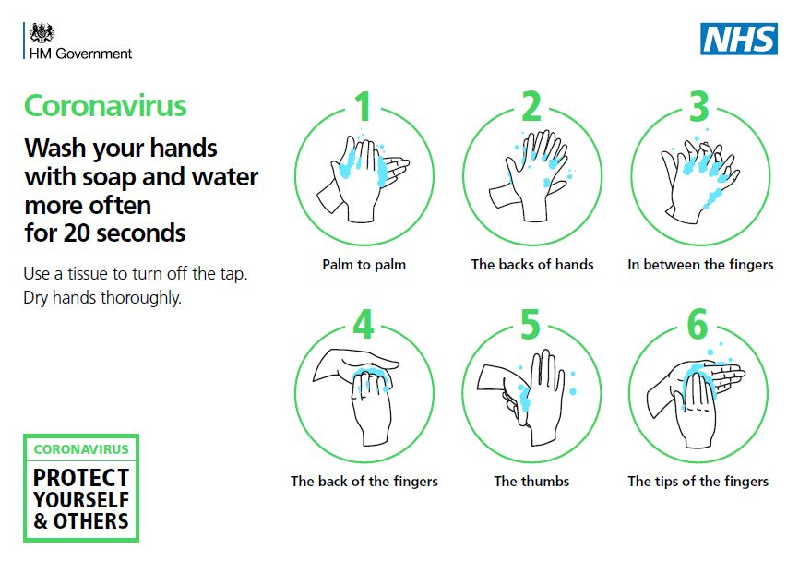

**Appendix 2 – PPE**

**PPE Types and rationale for use**

Taken from <https://www.gov.uk/government/publications/wuhan-novel-coronavirus-infection-prevention-and-control/covid-19-personal-protective-equipment-ppe>

**Fluid Resistant Surgical Masks**

Fluid-resistant (Type IIR) surgical masks (FRSM) provide barrier protection against respiratory droplets reaching the mucosa of the mouth and nose.

Surgical masks should:

* cover both nose and mouth
* not be allowed to dangle around the neck after or between each use
* not be touched once put on
* be changed when they become moist or damaged
* be worn once and then discarded – hand hygiene must be performed after disposal

**Eye and face protection**

Eye and face protection provides protection against contamination to the eyes from respiratory droplets, aerosols arising from AGPs and from splashing of secretions (including respiratory secretions), blood, body fluids or excretions.

Eye and face protection can be achieved by the use of any one of the following:

* surgical mask with integrated visor
* full face shield or visor
* polycarbonate safety spectacles or equivalent

Regular corrective spectacles are not considered adequate eye protection.

**Disposable aprons and gowns**

Disposable plastic aprons must be worn to protect staff uniform or clothes from contamination when providing direct patient care and during environmental and equipment decontamination.

**Disposable gloves**

Disposable gloves must be worn when providing direct patient care and when exposure to blood and or other body fluids is anticipated or likely, including during equipment and environmental decontamination. Disposable gloves are subject to single use and must be disposed of immediately after completion of a procedure or task and after each patient contact. Double gloving is not necessary.

**Sessional use of PPE**

Aprons and gloves are subject to single use as per Standard Infection Control Precautions (SICPs), with disposal and hand hygiene after each patient contact. Respirators, fluid-resistant (Type IIR) surgical masks (FRSM), eye protection and disposable fluid repellent coveralls or long-sleeved disposable fluid repellent gowns can be subject to single sessional use.

A single session refers to a period of time where a health and social care worker is undertaking duties in a specific clinical care setting or exposure environment. For example, a session might comprise a ward round, or taking observations of several patients in a cohort bay or ward. A session ends when the health and social care worker leaves the clinical care setting or exposure environment. Once the PPE has been removed it should be disposed of safely. The duration of a single session will vary depending on the clinical activity being undertaken.

While generally considered good practice, there is no evidence to show that discarding disposable respirators, facemasks or eye protection in between each patient reduces the risk of infection transmission to the health and social care worker or the patient. Indeed, frequent handling of this equipment to discard and replace it could theoretically increase risk of exposure in high demand environments, for example, by leading to increasing face touching during removal. The rationale for recommending sessional use in certain circumstances is therefore to reduce risk of inadvertent indirect transmission, as well as to facilitate delivery of efficient clinical care.

PPE should not be subject to continued use if damaged, soiled, compromised, uncomfortable or in other circumstances outlined in [section 10](https://www.gov.uk/government/publications/wuhan-novel-coronavirus-infection-prevention-and-control/covid-19-personal-protective-equipment-ppe#section-10), and a session should be ended. While the duration of a session is not specified here, the duration of use of PPE items should not exceed manufacturer instructions. Appropriateness of single versus sessional use is dependent on the nature of the task or activity being undertaken and the local context.

In the context of Old Park School, sessional use is defined as:

* Morning in class, not exiting the room (PPE should be changed after staff lunch)
* Afternoon in class, not exiting the room
* Exiting the room to carry out intimate care
* Exiting the room for other reason

**Donning and Doffing PPE Guidance**

Old Park School staff have been directed by Dudley LA Health and Safety team to watch the following video - <https://www.youtube.com/watch?v=-GncQ_ed-9w&feature=youtu.be>

Old Park School have sought the following additional online training for all staff - <https://www.highspeedtraining.co.uk/health-and-safety/ppe-training-for-healthcare.aspx>

Old Park School Nurse will carry out a face to face briefing with all staff to ensure competence and confidence.

The following information is taken from COVID-19: Guidance on the ordering of personal Protective Equipment, (PPE) and other supplies and how to use them.

<https://connect.dudley.gov.uk/documents/_layouts/15/WopiFrame.aspx?sourcedoc=/documents/shared/Communications-and-Public-Affairs/Guidance%20for%20the%20ordering%20of%20PPE%20and%20other%20supplies%2017.04.20.docx&action=default>

When using PPE it is important that it is applied and removed in the correct order, as there is a risk that the user can be contaminated. It is important that all staff are aware of this procedure.

How to put on Personal Protective Equipment (PPE)

Thorough hand washing technique must be performed or if unavailable use hand sanitizer, before putting on any PPE and then put on in the following order:

1. Apron

2. FRSM if worn

3. Eye protection if worn (your prescription glasses are not PPE)

4. Gloves

Please remove PPE in the following order

1. Gloves – because these are the most contaminated

2. Apron

3. Eye protection if worn (your prescription glasses are not PPE)

4. FRSM

Cleaning

* Eye protection should where possible be disposable and disposed of following s single care episode or session. If not they should be cleaned using a standard detergent and a chlorine releasing agent. As detailed below.

* Clean the environment to minimize the spread as current evidence suggests that the virus can stay on surfaces for up to 72 hours.

* Wear disposable apron and gloves for cleaning.

Laundry – In a non-healthcare setting

* Do not shake dirty laundry - this minimises the possibility of dispersing virus through the air.

* Wash items as appropriate, in accordance with the clothing manufacturer’s instructions.

* Dirty laundry that has been in contact with a person suspected or diagnosed with COVID can be washed with other household member’s laundry.

Disposal of Waste

* Any waste generated should be set aside in a waste bag for 72 hours, before being placed in the household rubbish

The following posters are taken from <https://www.gov.uk/government/publications/covid-19-personal-protective-equipment-use-for-non-aerosol-generating-procedures>

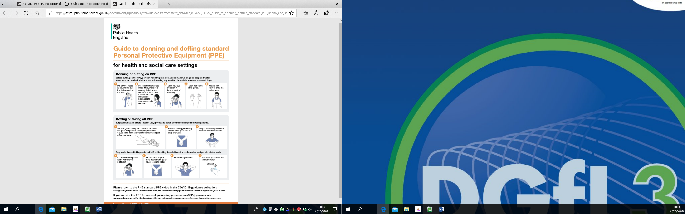

<https://assets.publishing.service.gov.uk/government/uploads/system/uploads/attachment_data/file/877658/Quick_guide_to_donning_doffing_standard_PPE_health_and_social_care_poster__.pdf>

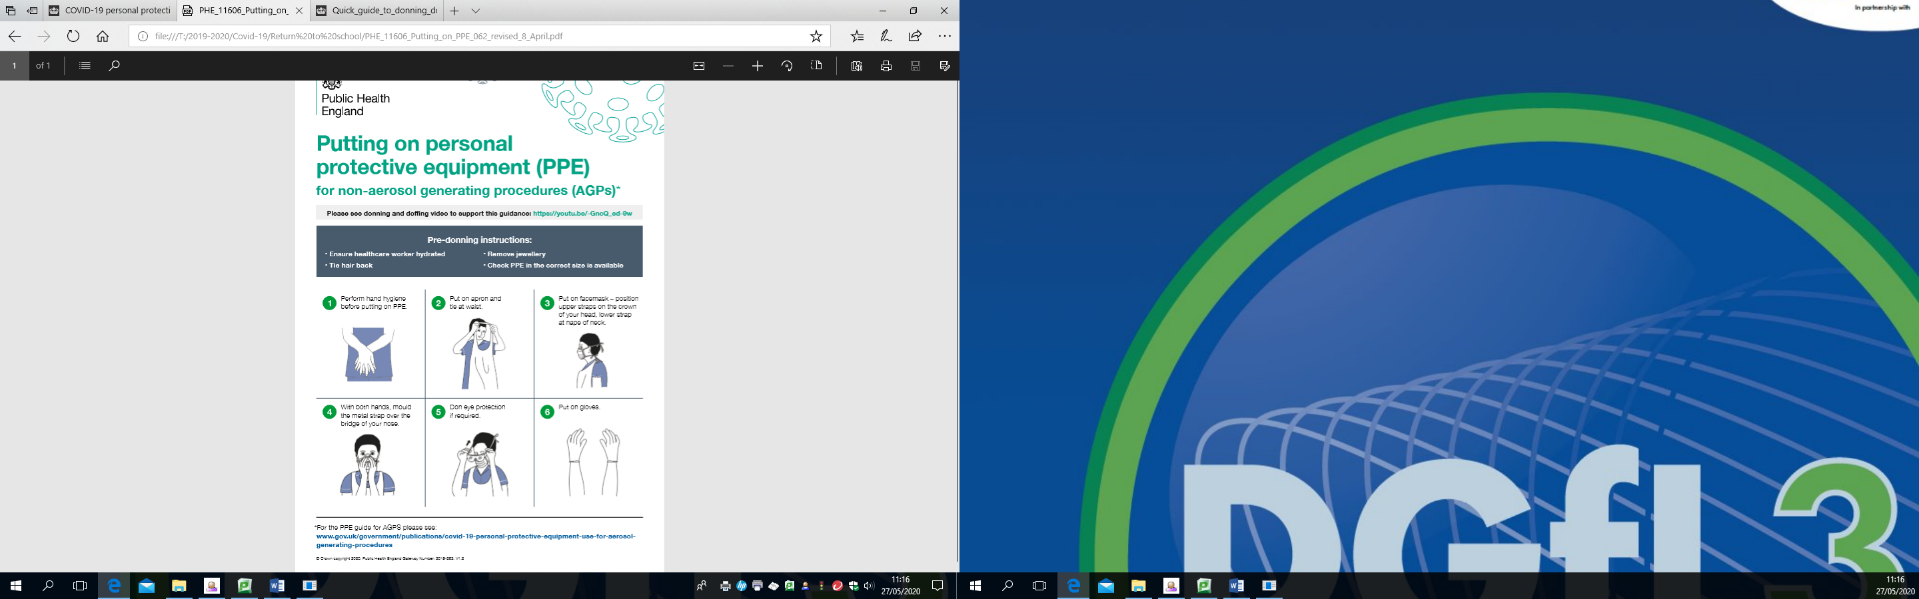

<https://assets.publishing.service.gov.uk/government/uploads/system/uploads/attachment_data/file/878677/PHE_11606_Putting_on_PPE_062_revised_8_April.pdf>

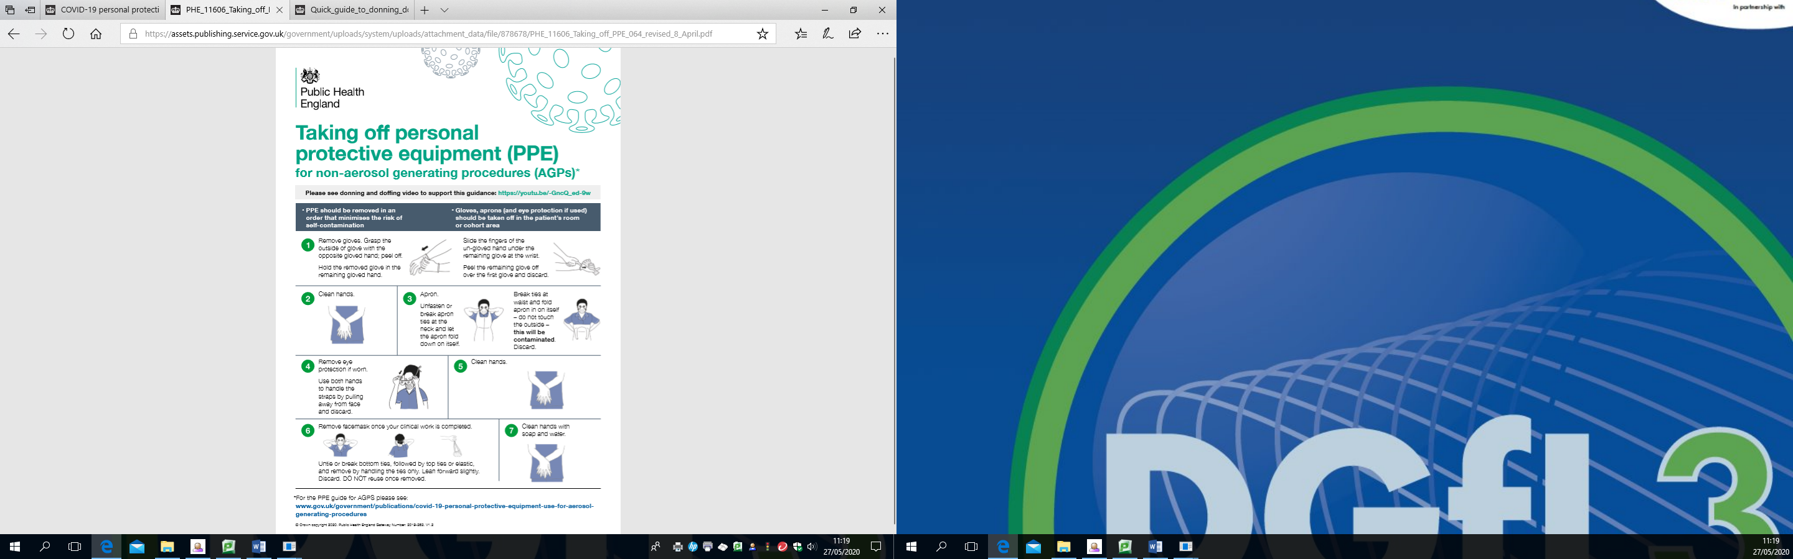

<https://assets.publishing.service.gov.uk/government/uploads/system/uploads/attachment_data/file/878678/PHE_11606_Taking_off_PPE_064_revised_8_April.pdf>

**Appendix 3**

Old Park School policies impacted by this risk assessment are as follows –

Attendance

Behaviour Management and Physical Intervention

Curriculum

Educational Visits Offsite

Health and Safety including Infection Control and First Aid

Home/School Communication

Intimate Care

Managing Medical Needs in School

Remote Learning

Safeguarding

Safer People Moving and Handling

Transport

Visitors in School

**Appendix 4 Updated Definition of Contact (02.12.2020)**

Public Health England (PHE) has recently updated its definition of a ‘contact’ to include individuals who have been within 2 metres of someone who has tested positive for Covid-19 on multiple occasions during a single day for at least 15 minutes in total. In particular, this may affect staff who spend time with colleagues for short periods throughout the day. The best way to avoid being a contact is to maintain a 2 metre distance from others wherever possible.  
  
Non-household contacts include any person who has had any of the following types of contacts with someone who has tested positive for Covid-19:

* face-to-face contact (within one metre), including: being coughed on, having a face-to-face conversation within one metre*
* skin-to-skin physical contact for any length of time
* been within one metre for one minute or longer without face-to-face contact*
* been within 2 metres of someone who has tested positive for COVID-19 for more than 15 minutes* as a one-off exposure.
* been within 2 metres of someone who has tested positive for COVID-19 on multiple occasions during a single day (midnight to midnight) for at least 15 minutes in total (when all times added up together)
* travelled in a small vehicle together, or in a large vehicle or plane near someone*